# IPL Data Analytics & Reporting using Excel

SUMMARY PPT

**Subject**: Data Analytics and Reporting **Prepared by**: Aman Kushwaha(202410101150081)

: Faisal Ansari(202410101150078)

**Course**: B.Tech CSE(DS+AI),Group:- 33

# Project Objective

* *To analyze IPL match performance data using Excel to identify trends, top-performing teams and players, and visualize results through pivot tables and dashboards.*

# Dataset Description

* • Dataset Name: IPL_Analysis_Data.xlsx
* • Rows: 1,200
* • Columns: 12
* • Seasons: 2018–2023
* • Data Fields: Match_ID, Team_Batting, Team_Bowling, Batsman, Bowler, Over, Runs, Wickets, etc.
* • Dataset generated using realistic IPL match data.

# Data Cleaning Steps

* + • Removed duplicates
  + • Handled missing values (replaced with 0 or NA)
  + • Formatted column names and data types
  + • Added filters for easy analysis

***After performing data Cleaning step we got this data set***

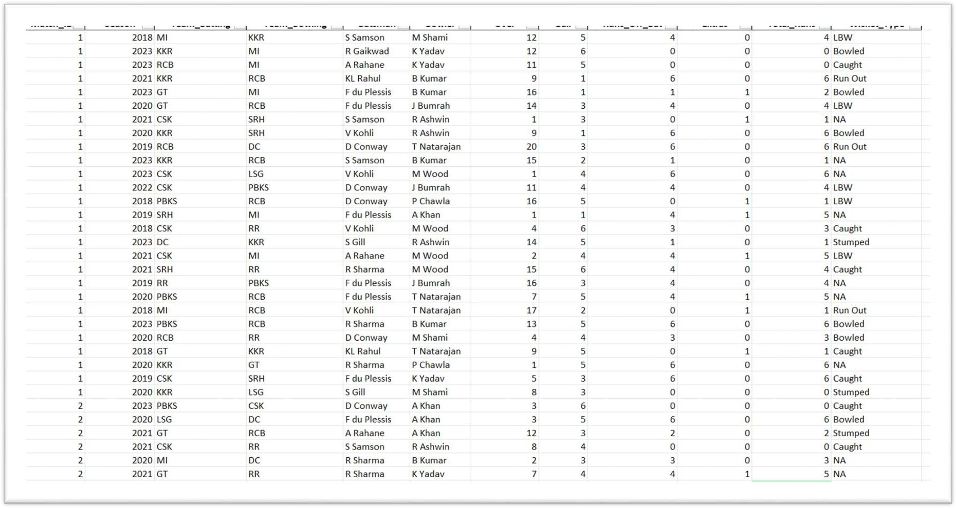

# Formulas and Functions Used

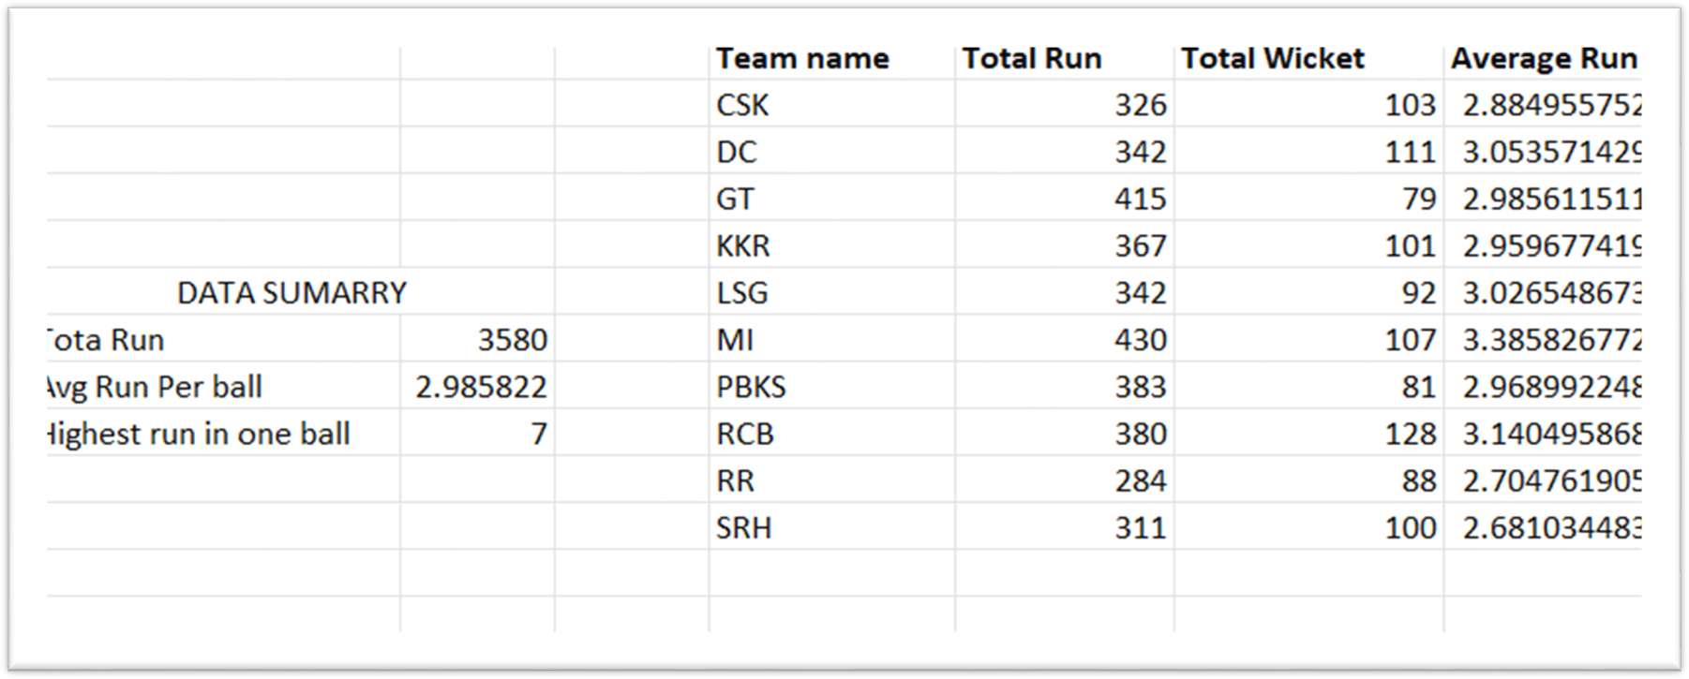

* • SUM(), AVERAGE(), MAX(), MIN()
* • COUNTIF(), SUMIF(), AVERAGEIF()
* • IF() for classifying high/low performers

***Conditional Formatting for highlighting top***

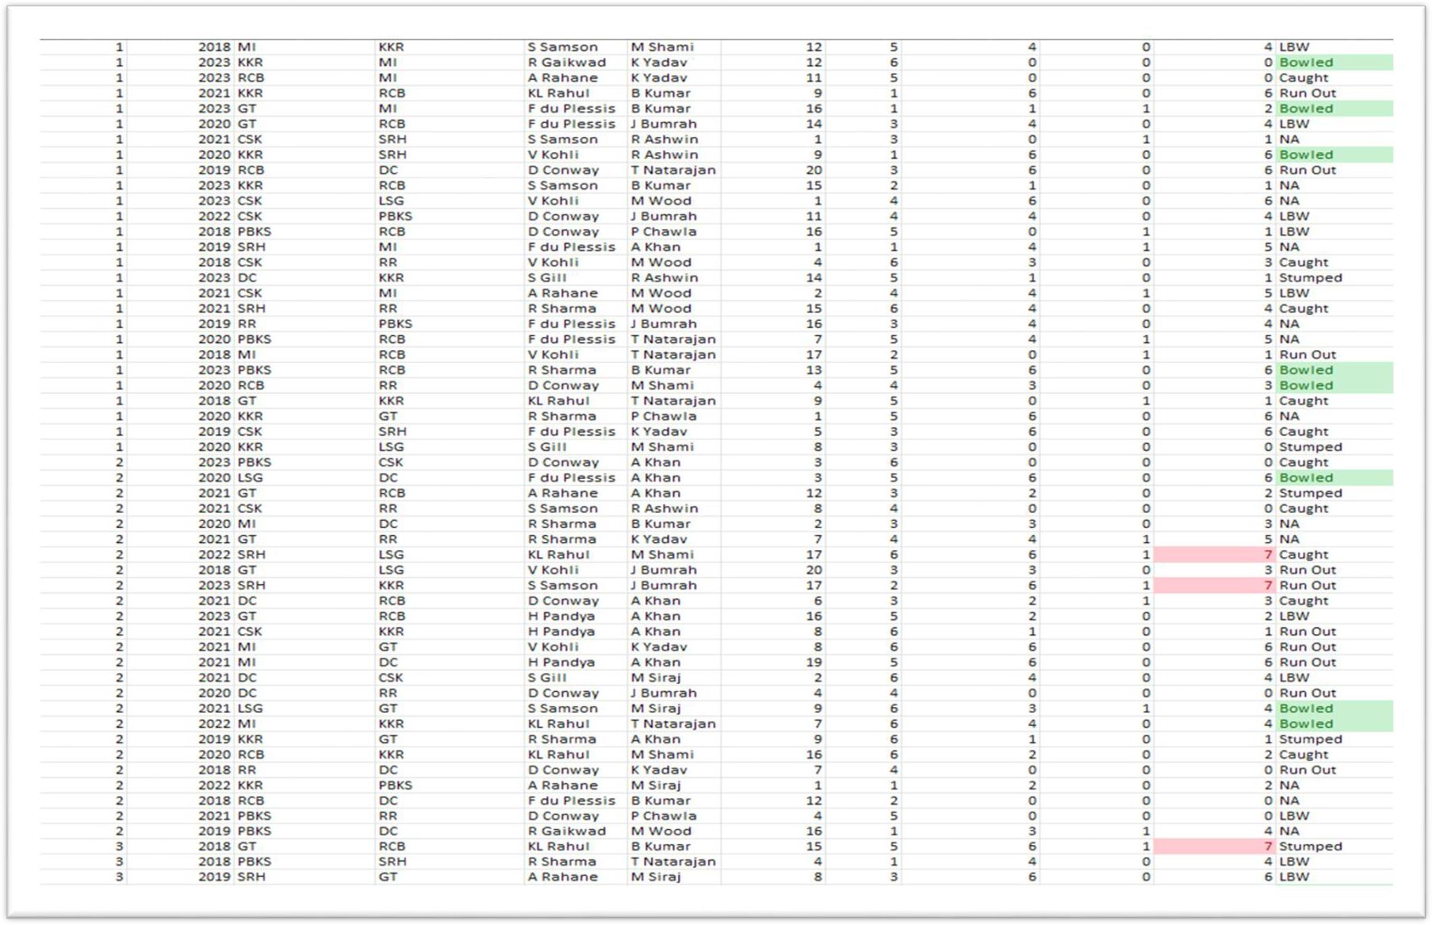

***scores and wicket***

# Pivot Table Analysis

* + • Total Runs by Batting Team=3580

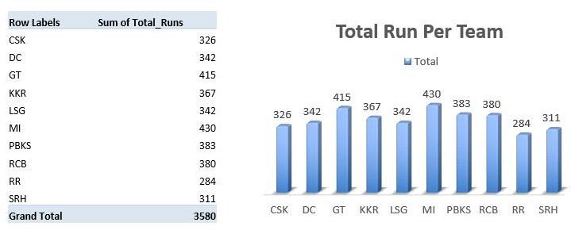

### Highest Score on one Ball

* + ***Total Run, Average Run per Ball***

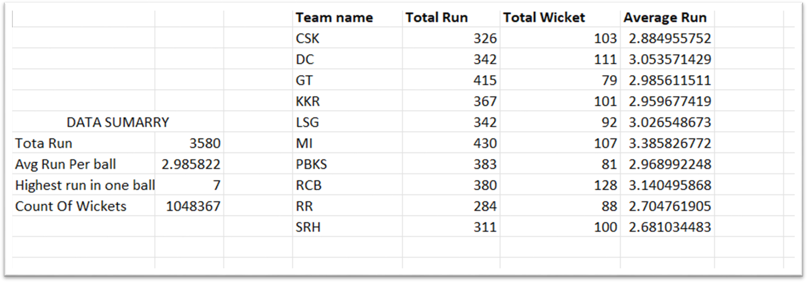

2018

A RAHAN E D CONWAY

2020

2022

2018

2020

6675

92

65

93

71

29

85

36

2022

2018

2020

2022

2018

62

41

39

67

79

104

30

**TOTAL**

35

95

67

34

H PAN DYA KL RAHUL

2020 65

43

**RUN**

2022 59

62

2018 69

61

2020 48

28

2022

48

2018 41

56

2020 74

**BY**

**BATSMAN**

114

44

2022 52

36

2018 60

67

R SHARMA

2020 79

89

**PER**

2022 56

59

2018 63

41

2020 58

**SEASON**

S GILL

46

2022 53

58

2018 57

33

S SAMSON

2020 30

88

2022

2018

2020

V KOHLI

2022

35

54

60

50

105

65

60

49

Total

***Created Pivot Tables for quick summarization of***

***Total Run By Batsman per season***

F DU

PLESSIS

R

GAI KWAD

# Charts and Visualizations

### Column Chart –Batsman-wise Total Runs

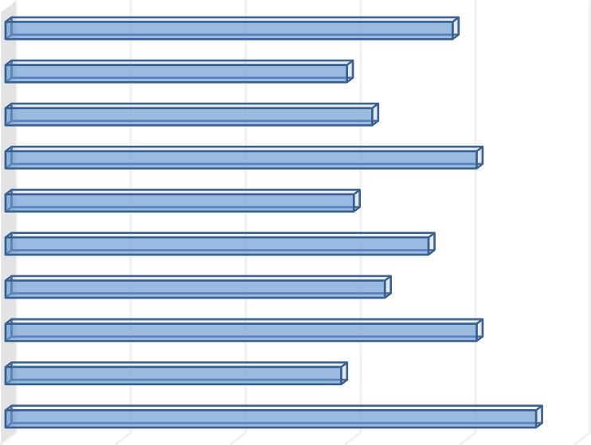Total Run By Batsman

|  |  |
| --- | --- |
| **Row Labels** | **Sum of Total_Runs** |
| A Rahane | 462 |
| D Conway | 292 |
| F du Plessis | 410 |
| H Pandya | 330 |
| KL Rahul | 368 |
| R Gaikwad | 303 |
| R Sharma | 410 |
| S Gill | 319 |
| S Samson | 297 |
| V Kohli | 389 |
| **Grand Total** | **3580** |

|  |  |  |  |  |  |
| --- | --- | --- | --- | --- | --- |
| V Kohli |  |  |  | 389 |  |
| S Samson |  |  | 297 |  |  |
| S Gill |  |  | 319 |  |  |
| R Sharma |  |  |  | 410 |  |
| R Gaikwad |  |  | 303 |  |  |
| KL Rahul |  |  |  | 368 |  |
| H Pandya |  |  | 330 |  |  |
| F du Plessis |  |  |  | 410 |  |
| D Conway |  |  | 292 |  |  |
| A Rahane |  |  |  |  | 462 |
| 0 | 100 | 200 | 300 | 400 | 500 |

 Total

Highest Scoring Batsman is :- A Rahane, F de Plessis and R Sharma

### Pie Chart – % of Wickets per Bowler

#### TOTAL WICKET BY BOWLER

**R Ashwin 9%**

**T Natarajan**

**11%**

**A Khan**

**10%**

**B Kumar 11%**

**P Chawla 9%**

**M Wood 10%**

**J Bumrah 8%**

**K Yadav 11%**

**M Siraj 10%**

**M Shami 11%**

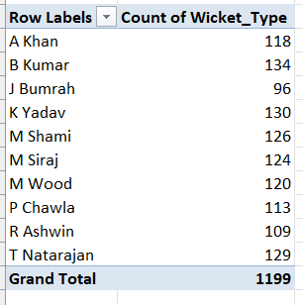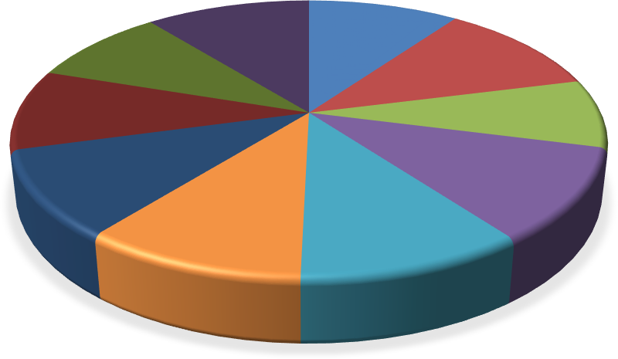

Highest Scoring Bowler is:- M Shami , T Natarajan and K Yadav

### Line Chart – Season-wise Run Trends

800

|  |  |
| --- | --- |
| **Row Labels** | **Sum of Total_Runs** |
| 2018 | 579 |
| 2019 | 581 |
| 2020 | 691 |
| 2021 | 560 |
| 2022 | 598 |
| 2023 | 571 |
| **Grand Total** | **3580** |

700

600

500

400

300

200

#### TOTAL RUNS TREND BY SEASON



Total

100

0

2018



691

579

581

560

598

571

2019 2020

2021

2022

2023

Run in Season 2020 is the Highest

### Count of wicket per wicket type

220

|  |  |
| --- | --- |
| **Row Labels** | **Count of Wicket_Type** |
| Bowled | 195 |
| Caught | 180 |
| LBW | 206 |
| NA | 209 |
| Run Out | 197 |
| Stumped | 212 |
| **Grand Total** | **1199** |

210

200

190

180

170

160

Total Wicket Per Wicket Type

212

Bowled Caught LBW NA Run Out Stumped



206

209

195

180

197

 Total

Stumped is highest Wicket Type

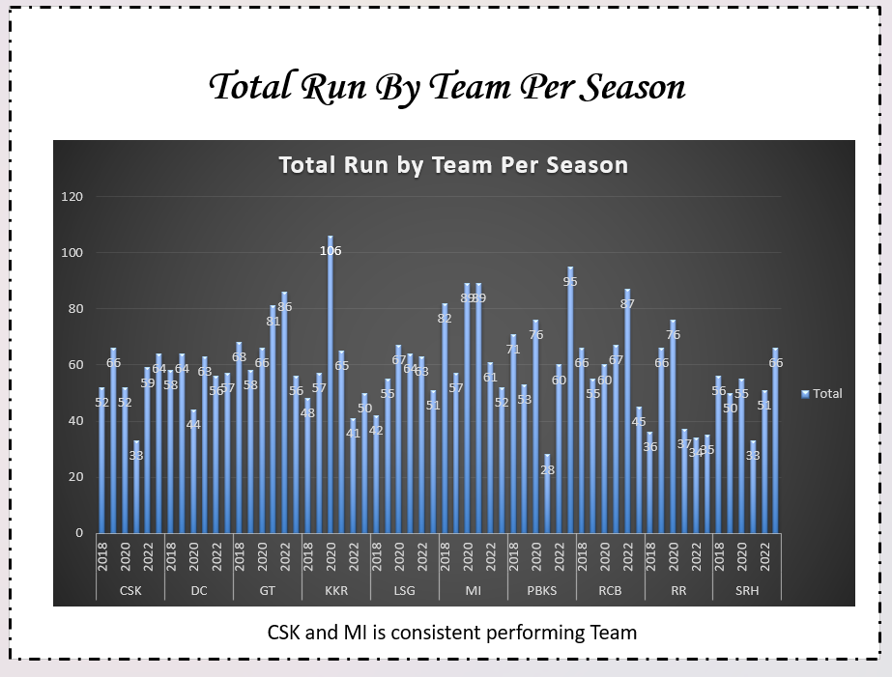

#### TOTAL WICKET PER OVER

65

79

68

71

75

61

64

68

|  |  |
| --- | --- |
| **Row Labels** | **Count of Wicket_Type** |
| 1 | 58 |
| 2 | 56 |
| 3 | 65 |
| 4 | 79 |
| 5 | 68 |
| 6 | 59 |
| 7 | 50 |
| 8 | 71 |
| 9 | 59 |
| 10 | 59 |
| 11 | 43 |
| 12 | 57 |
| 13 | 50 |
| 14 | 75 |
| 15 | 61 |
| 16 | 64 |
| 17 | 55 |
| 18 | 52 |
| 19 | 68 |
| 20 | 50 |
| **Grand Total** | **1199** |

 Total

58

56

59

50

59

59

43

57

50

55

52

50

1 2 3 4 5 6 7 8 9 10 11 12 13 14 15 16 17 18 19 20

Most Wicket Are Taken in 4,8 and 14 Over

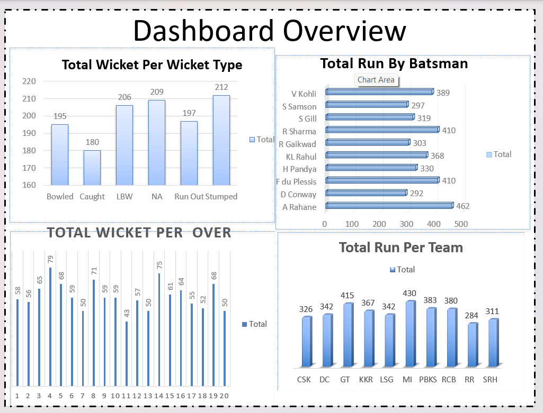

***IPL PERFORMANCE DASHBOARD***

# 

***IPL PERFORMANCE DASHBOARD***

# Insights & Findings

* • MI recorded the highest total runs
* • B Kumar and K Yadav took most wickets
* • Average runs per ball ≈ 2.98
* • Most wickets occurred in overs 4,8,14
* • ‘Stumped' was the most frequent wicket type
* • CSK and MI are consistent scoring teams

***Conclusion & References***

* • Successfully analyzed IPL match data using Excel tools
* • Identified top players and team performances
* • Created interactive visualizations for reporting
* References:
* • Dataset generated using Python simulation
* • IPL reference: [www.iplt20.com](http://www.iplt20.com/)